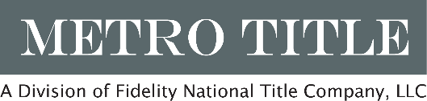
3101 Glenwood Ave, Ste 104
Raleigh, NC 27612
Tel: 919-833-1284
www.mettitle.biz

IDENTITY AFFIDAVIT

To: Metro Title Company, LLC and either First American Title Insurance Company, Commonwealth Land Title Insurance Company or Stewart Title Guaranty Company (collectively hereinafter “Title Company”)

WHEREAS, Title Company is about to issue its title insurance commitment and/or policy(ies), insuring against loss by reason of defects in the title to the premises described as follows (the “Property”):

AND, WHEREAS, Title Company has noted as exception(s) to the aforesaid title the following judgment(s), lien(s) or civil action(s) (hereinafter “Title Matter”):

AND, WHEREAS, the Indemnitor states that they are not the same person(s) against whom said Title Matter was filed;

NOW, THEREFORE, the Indemnitor hereby requests the Title Company to issue its policy or policies of title insurance with reliance upon the above statement(s) and in consideration thereof, and as an inducement therefore, said Indemnitor does hereby agree to indemnify and hold the Title Company harmless of and from any and all loss, cost, damage and expenses of every kind, including attorney’s fees, which the Title Company shall or may suffer or incur or become liable for under its said policy or policies now to be issued, or any re-issue, renewal or extension thereof, or new policy at any time issued upon said real estate, a part thereof or interest therein, arising directly or indirectly, out of or on account of the above-referenced Title Matter or in connection with its enforcement or its rights under this agreement.

In witness whereof this instrument has been executed this __________ day of _________________, 200___.

EXECUTION BY INDEMNITOR

ENTITY NAME  By:  Printed/Typed Name:  Title:  STATE OF COUNTY OF  Sworn to and subscribed before me this the  day of , 20 .  Name: ,Notary Public  My Commission Expires:  Notary Seal | (SEAL)  Printed/Typed Name:  (SEAL)  Printed/Typed Name:  (SEAL)  Printed/Typed Name:  (SEAL)  Printed/Typed Name:

